2022 Personal Finance Case Study
Each team will have two (2) hours to work together to come up with a financial plan based on a detailed fictitious family scenario. Each team will create a digital presentation and present to a panel of expert judges. Presentations are limited to fifteen (15) minutes and an additional five (5) minutes to respond to questions.

- Teams will be provided with the same fictitious family scenario (case study).
- NO cell phones/smart watches can be used during the two-hour case study work time. All communication must between team members and must be made live in the Zoom room. No outside contact is allowed.
- Each Zoom room will be monitored by a proctor.
- Students are responsible for their own stable Wi-Fi access and presentation software.
- Teams are welcome to use any presentation software they have access to: PowerPoint, Google slides, etc.

COMPETITION INTEGRITY

Students are asked to create a financial plan for a detailed fictitious family scenario (case study). Students will present to and answer questions from an expert panel of judges comprised of economists and financial professionals.

It is our desire to ensure that fair competition exists at all levels. If a student or proctor/teacher is caught cheating the team will be disqualified. The following are strictly prohibited and will result in disqualification and immediate removal from the competition.

- Communication between the students and teachers during the case study preparation time/two (2) hour work time. Including using technology like smart watch/smart phone/chat feature to “phone a friend.”
- Any discussion of the case study or presentation during breaks.
- Accessing any previously saved data, research, or other files on a personal laptop or online, including Dropbox or Google Drives, for use on the case study or presentation.
- Use of cell phones/smart watches during the two-hour case study work time.
- In this virtual environment, even the appearance of impropriety will lead to disqualification.

Family Scenario
The Wilson Family needs your help. They have provided you their financial goals as well as their budget and balance sheet. Your job is to use this information to help improve their financial condition and reach their financial goals.
PERSONAL INFORMATION:
Ethan and Jessica Wilson live in Frederick, MD. They have two children: a son, Austin (age 12), who is in 7th grade, a daughter, Anna (age 10), who is a fifth grader at the neighborhood elementary school, and a daughter Julia who is 4 and attends pre-school. Ethan (age 44) received his B.A. in Business from Salisbury University and works as a Production Manager for manufacturing business. Jessica, (age 42) attended Frederick Community College; however, she did not finish her degree. Right now, Jessica works in the hospitality industry and does not have stable hours.
The Wilson family has provided you with a current balance sheet and an estimated budget of their living expenses for the year 2022. These statements will show you the Wilson family’s current financial situation and how they manage their personal finances.
Additionally, Ethan and Jessica provided us with their answers to the behavioral finance questionnaire. Jessica is a saver while Ethan does pay attention to their budget. In the section about risk tolerance, Ethan is willing to take some risk in the stock market while Jessica does not know anything about investing. Jessica would like to continue with her education so that she can earn a certificate in construction management. They have found that their three-bedroom house is too small for their family and would like to move to a larger home.

INSTRUCTIONS
The Wilson Family has 3 goals. Their goals are to:
1. Complete college funding for both children (tuition and living expenses) and off student loan debt.
2. Increase their retirement savings in a way that both grows their account, but is also in line with their risk tolerance.
3. Cut expenses where possible, and better manage their debt.
4. Decide whether to buy a larger house.

In your oral presentation, please address the following:
- What are the main strengths and weaknesses of the Wilson family’s current financial condition?
  - How would you advise the Wilson family on the following?
    - managing their debt
    - managing their living expenses
    - purchasing a larger home
  - What advice would you provide regarding their disposable income?
  - What advice do you have about their approach to their retirements savings?
  - What advice do you have for funding both education expenses for both the children and Jessica?
- What would you advise Ethan and Jessica to do to meet their goals?
ADDITIONAL INFORMATION
Investment Assumptions:
Listed below are assumptions of future expected returns. This table is given to help you provide high-level guidance over how the Wilson family might consider allocating or diversifying their investment assets (retirement and education) based on their risk tolerances.
Asset Class | Expected Average  Annual Return
Large Cap Stocks | 11%
Mid-Cap and Small-Stocks | 12%
International Equities | 13%
Emerging Market Equities | 14%
International Bonds | 7%
Long term Bonds Domestic | 5%
Long-term Treasuries | 3.1%
Short-term Treasuries | 1.9%
Money Market Funds | 0.25%

EDUCATION
Ethan and Jessica want to provide financial support (tuition and fees, books, room and board) for each of their children to a four-year in-state university; however, they have not set up college savings accounts for either child.
RETIREMENT
Ethan and Jessica plan to retire at age 68.
Ethan also has a 401(k) invested with T. Rowe Price. The current market value of his account is $100,000. He is contributing $400 per month into his 401(k). His employer has a matching program up to 50%
Jessica’s employer does not provide a retirement program; however, she does contribute to an IRA.

 | Circle the corresponding # & add up all 5 criteria in the Judged score column | Little/no Value | Below Expectations | Meets Expectations | Exceeds Expectations | Judged Score
Judging Criteria – Considerations include, but are not limited to the bulleted items
1. | Understand and address client’s goals & concerns – 25%  - Attention to all elements of the task  - Application of financial concepts as relevant  - Presentation of logical arguments | 0-8 | 9-14 | 15-20 | 21-25
2. | Background Knowledge – 15%  - Evidence of knowledge of financial content necessary to address the problem  - Evidence of knowledge of financial issues necessary to address the problem | 0-4 | 5-8 | 9-12 | 13-15
3. | Financial Analysis & Insights – 25%  - Evidence of thinking comprehensively about the issues  - Evidence of thinking critically about underlying assumptions where relevant | 0-8 | 9-14 | 15-20 | 21-25
4. | Presentation – 20%  - Overall quality of presentation  - Evidence of teamwork and coordination  - Evidence of participation by all team members  - Clarity of presentation  - Creativity  - Professionalism (organization, appearance/demeanor) | 0-5 | 6-10 | 11-15 | 16-20
5. | Responses to Judge’s Questions – 15%  - Evidence of sufficient knowledge to answer questions posed  - Evidence of analytical strengths in responses | 0-4 | 5-8 | 9-12 | 13-15
Total Score
Judge’s Scoring Rubric

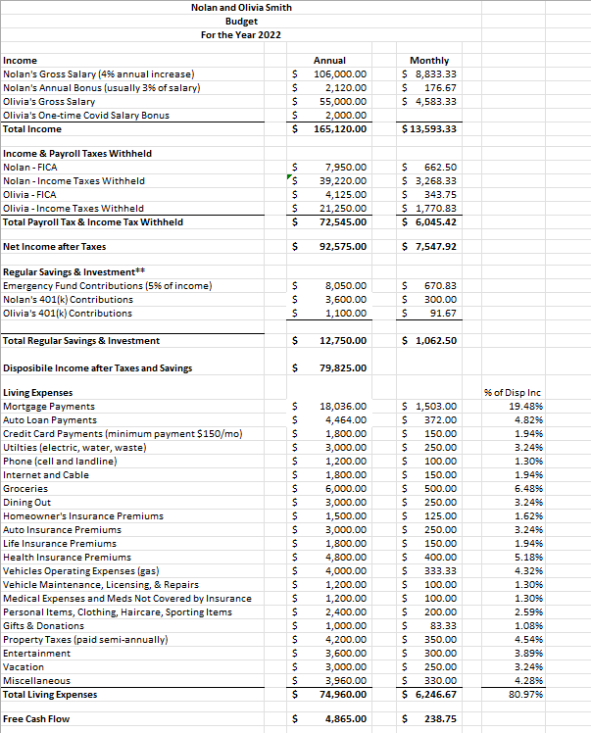
.

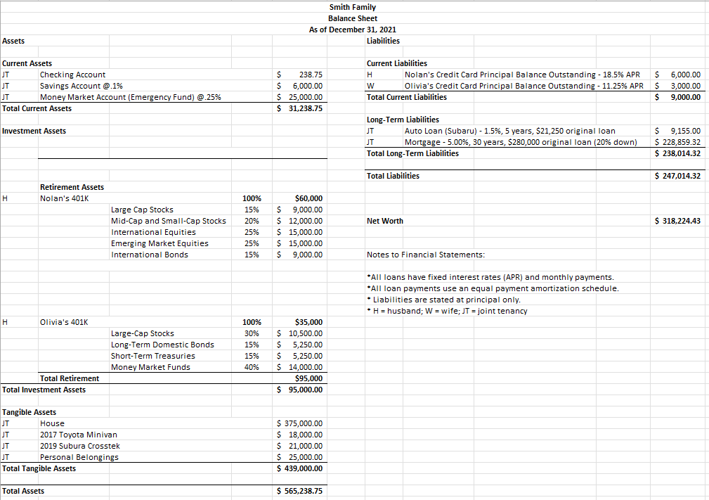

 |  | Little/no Value | Below Expectations | Meets Expectations | Exceeds Expectations | Judged Score
1. | Understand and address client’s goals & concerns – 25%  - Attention to all elements of the task  - Application of financial concepts as relevant  - Presentation of logical arguments | 0-8 | 9-14 | 15-20 | 21-25
2. | Background Knowledge – 15%  - Evidence of knowledge of financial content necessary to address the problem  - Evidence of knowledge of financial issues necessary to address the problem | 0-4 | 5-8 | 9-12 | 13-15
3. | Financial Analysis & Insights – 25%  - Evidence of thinking comprehensively about the issues  - Evidence of thinking critically about underlying assumptions where relevant | 0-8 | 9-14 | 15-20 | 21-25
4. | Presentation – 20%  - Overall quality of presentation  - Evidence of teamwork and coordination  - Evidence of participation by all team members  - Clarity of presentation  - Creativity  - Professionalism (organization, appearance/demeanor) | 0-5 | 6-10 | 11-15 | 16-20
5. | Responses to Judge’s Questions – 15%  - Evidence of sufficient knowledge to answer questions posed  - Evidence of analytical strengths in responses | 0-4 | 5-8 | 9-12 | 13-15
Total Score
JUDGING RUBIC

